Question 1
Effects of a Change in the NJ Minimum Wage
N= 322 fast food restaurants before and after wage increase
Wage Change = $4.25 to $5.05 per hour
- Estimate the mean change in full time equivalent employees per restaurants and the variance in this change.
The mean change in full time equivalent employees per restaurants = 0.798757764
The variance in the change in full time equivalent employees per restaurants = 77.49766
- Does the data suggest employment change?
Yes, the data does suggest employment changes. The variance of 77.498 is a high positive value that indicates the spread of values tend to be away from the mean. A lower or small variance indicates the data points being close to the mean, and to each other’s.

- Explain briefly why this might not answer the question of interest.
The question was interested in answering whether the level of the minimum wage affects employment. The mean change in full time equivalent employees per restaurant does not answer effect of wages on employment and neither does the variance. Variance establishes dispersion between data points from the mean, not any relation between employment and wages.

Question 2
Minimum wage on employment, we compare the change in employment in New Jersey and with that of Pennsylvania which saw no change in the minimum wage over the period.

The mean change in full time equivalent employees per restaurant in Pennsylvania = -1.90584.
The variance in the change in full time equivalent employees per restaurant in Pennsylvania = 122.4787.

Yes, the change in employment in New Jersey statistically different from that in Pennsylvania assuming the variances are different. New Jersey has a mean of 0.798757764 while Pennsylvania mean is -1.90584. The means indicate the statistical difference between the two towns.
- Test the assumption of different variances and make any adjustments to the previous part that this suggests.
If we were to consider the variance as they are without assuming different variances, there is no statistical difference between the variances. The variances indicate a change in minimum wages affect the employment of people in the two cities.
- How might this enable us to address the impact of the minimum wage on employment better than I the first question and what issues might remain?
The two samples indicate a difference in mean but a similarity in variance. Variance indicates that both city employees had a change in their minimum wage although the means indicate different directions. What the sample does not tell us is which direction the changes are because both variances are positive which indicates a positive change. The issue arising from these results is to establish which direction changes of minimum wage affect the employment decision. However, logically we can describe an increase in minimum wage as an increase in employment rates.
Question 3
Dependent variable is the change in full time equivalent employees per fast food restaurant before and after the change in minimum wage
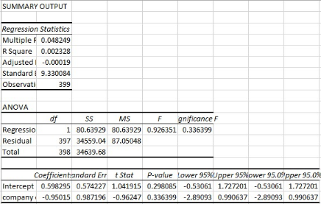
Estimate the regression below
EmploymentChange₁ = - 0.95015 + 0.598295 NJ₁ + B₂CompanyOwned_{i} + e_{i}.
- How do you interpret the coefficient estimate and the R?
R squared is 0.028227 indicates that the data set does not fit within a linear regression model, therefore, the model cannot be explained by the mode of the data set. The change in minimum wage does not account to employment due to the nature of company ownership.

- Are the coefficient estimates statistically significant?
Yes, the coefficient estimates are statistically significant.
- What does the F-test tell us?
F test tell us that there is a relationship between change in full time equivalent employees per fast food restaurant before and after the change in minimum wage. The test identifies a significant relationship between the wage increase and company ownership as important factors for employment.
- Do these results agree with the previous question and if not why might this be?
These results do not agree with the previous question because the previous question only compared wage increase among two countries and not the effects of wage increase between the factors of employment.
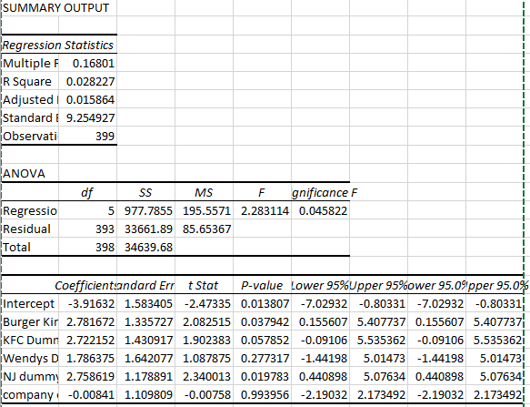
EmploymentChange_{i} = B₀ +B₁NJ₁ + B₂CompanyOwned_{i} + B₃BurgerKing_{i}+B₄KFC_{i} + B₅ Wendys_{i} + e_{i.}
EmploymentChange_{i} = B₀ +B₁ (2.758619) + B₂ (-0.00841) + B₃ (2.781672)+B₄ (2.722152)+ B₅ (1.786375) + e_{i.}
- Compare this regression to that of part a?
In part a, we were interested in employment change against the company ownership with regard to the minimum wage increase. However, these regression defines all the variables and how they affect employment change in New Jersey. A comprehensive analysis of all the factories without making assumptions. The

- Explain why this might not answer the question of the effect of the minimum wage on employment and how might we address any remaining issues?
The regression analysis in these part will not fully answer the question of the effect of the minimum wage on employment because other factors are not involved in these analysis. These factors of employment that are not related to minimum wage include; job qualification, personal interest, employees turnover per company, recruitment criteria among others. In order to fully encompass these study about change in employment due to minimum wage increment, we ought to focus solely on employee’s perception of increment in wages and how it affects their performance.

